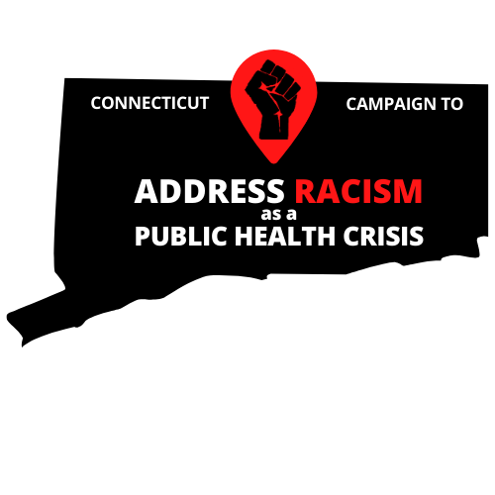

Email/letter Sample

My name is [Your Name] and I am a constituent of [City/Town]. I am writing to show my support of H.B. No. 6662: An Act Declaring Racism as a Public Health Crisis and Establishing the Commission on Racial Equity in Public Health.

This matters to me because [Add personal story/beliefs/ethical-moral mandates]

Systemic and structural racism play a large role in determining the conditions in which people are born, grow, work, live, and age, and affects people’s access to quality housing, education, food, transportation, political power, and other social determinants of health. Racism also has negative mental and physical health consequences such as, depression, anxiety, hypertension, preterm birth, shortened life span and poor quality of life. Understanding and addressing racism from this public health perspective is crucial to eliminating racial and ethnic inequities, and improving opportunity and well-being across communities.

H.B. 6662 is an opportunity for our state to lead the pursuit for racial justice with action. I stand with the Connecticut Campaign to Address Racism as a Public Health Crisis and ask that this bill be amended to include a review and reform of the legislative process to improve public accessibility and set in place mechanisms to determine the impact of proposed legislation on race.

In closing, I urge you to support H.B. No. 6662 An Act Declaring Racism as a Public Health Crisis and Establishing the Commission on Racial Equity in Public Health.