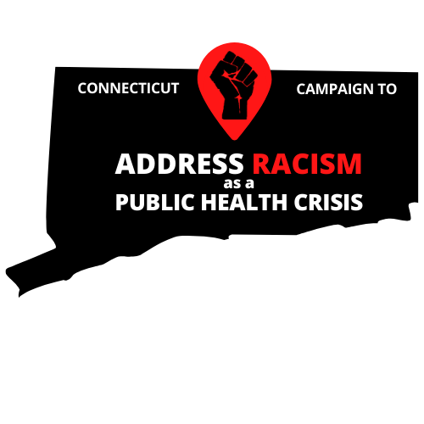

Email Script

Governor Ned Lamont

State of Connecticut

My name is [Your Name] and I am a constituent of [City/Town]. I am reaching out to encourage you to lead progressively and aggressively in the State of Connecticut by declaring racism a public health crisis by executive order.

Systemic and structural racism play a large role in determining the conditions in which people are born, grow, work, live, and age, and affects people’s access to quality housing, education, food, transportation, political power, and other social determinants of health. Racism also has negative mental and physical health consequences such as, depression, anxiety, hypertension, preterm birth, shortened life span and poor quality of life. Understanding and addressing racism from this public health perspective is crucial to eliminating racial and ethnic inequities, and to improving opportunity and well-being across communities.

[Add personal story]

Racism has been declared a public health crisis in 6 states, 182 municipalities, entities, and organizations, including 20 municipalities in Connecticut. Governor Lamont while legislators and community members work together to create transformative legislation to advance racial justice in our state, we need your leadership. Our state, particularly communities of color need to receive this declaration from your hand.

Governor Lamont, I ask that you declare racism a public health crisis in the state of Connecticut by executive order.